EXPT NO:6 | INTEGRATE DATA FROM VARIOUS SOURCES FOR COMPREHENSIVE ANALYSIS USING TABLEAU AND POWERBI
DATE: 24.07.2026

PRE-LAB QUESTIONS
1. What is data integration in the context of Business Intelligence (BI)?
Data integration is the process of combining data from multiple sources (databases, files, APIs) into a unified view, enabling comprehensive analysis and reporting that a single data source cannot provide.

2. Explain the difference between a join and a data blend in Tableau.
A join combines data at the source level (row-level combination, typically within the same connection), resulting in a single unified table. A data blend combines data from different data sources at the aggregate level, keeping them as separate queries linked by a common dimension.

3. What are relationships and cardinality (e.g., one-to-many, many-to-many) in Power BI's data model?
Relationships define how tables are connected via common fields. Cardinality describes the nature of that connection — one-to-many means one record in a table relates to multiple records in another, while many-to-many means multiple records in both tables can relate to each other.

4. Why is data quality (e.g., consistent naming conventions, data types) crucial when integrating data from different sources?
Poor data quality, like inconsistent naming (e.g., "N. America" vs. "North America") or mismatched data types, leads to failed joins, inaccurate aggregations, and unreliable insights. Consistency ensures accurate matching and analysis across sources.

5. Name two common challenges encountered during data integration.
Common challenges include mismatched keys/naming inconsistencies between datasets, and differences in data granularity (e.g., daily data vs. yearly targets) that complicate accurate comparison.

IN-LAB EXERCISE:
OBJECTIVE:
To connect to, combine, and model data from multiple disparate sources in Tableau and Power BI to create a unified, comprehensive dashboard for holistic analysis. PROCEDURE:
- Data Collection:
  - Import data from at least two different sources (e.g., a CSV file and an Excel file).
  - Dataset 1: Sales Data (CSV file) with fields like Order ID, Order Date, Region, Sales Amount.
  - Dataset 2: Regional Sales Targets (Excel file) with fields like Region, Sales Target, Target Year.
- Data Preparation and Transformation:
  - Clean both datasets: Check for inconsistencies in region names (e.g., "N. America" vs. "North America"). o Ensure data types are correct (e.g., Sales Amount is numeric, Order Date is a date).
  - Handle any missing values as appropriate.
- Data Integration and Modeling:
  - Tableau: Use the Data Source pane to establish a relationship or join between the Sales Data and Regional Targets tables using the common Region field.
  - Power BI: Use the Model view to create a relationship between the two tables, connecting them on the Region column. Define the cardinality (e.g., many-to-one).
- Create Calculated Fields for Comparison:
  - Develop new measures that leverage both datasets.
  - Examples: Target Achievement % = (SUM(Sales) / SUM(Sales Target)) * 100
  - Sales vs. Target Variance = SUM(Sales) - SUM(Sales Target)
- Design a Comprehensive Dashboard:
  - Create visuals that combine data from both sources to provide a single view of performance.
  - Add KPI cards for Total Sales and Overall Target Achievement %. o Use a gauge chart or bullet chart to show sales performance against targets for each region. o Create a combined bar chart showing Actual Sales vs. Target Sales by Region.
  - Use a map to visualize the Sales vs. Target Variance, highlighting underperforming or overperforming regions.
- Validate Data Integrity:
  - Verify that the joined/related data is accurate by cross-checking values. o Ensure filters on the dashboard correctly update visuals that use data from both sources.
- Publishing and Sharing:
  - Tableau: Publish the workbook to Tableau Public or Tableau Server.
  - Power BI: Publish the report to Power BI Service and share the link.
Experiment Datasets:
Dataset 1: Retail Sales Data (CSV) Fields Used:
- Order ID – Unique identifier for each order
- Order Date – Date of the sales transaction
- Region – Sales region
- Sales – Sales revenue from the order
Dataset 2: Regional Sales Targets (Excel) Fields Used:
- Region – Sales region (used as the key for joining/relationship)
- Sales Target – The sales goal for the region
- Target Year – The year for which the target is set

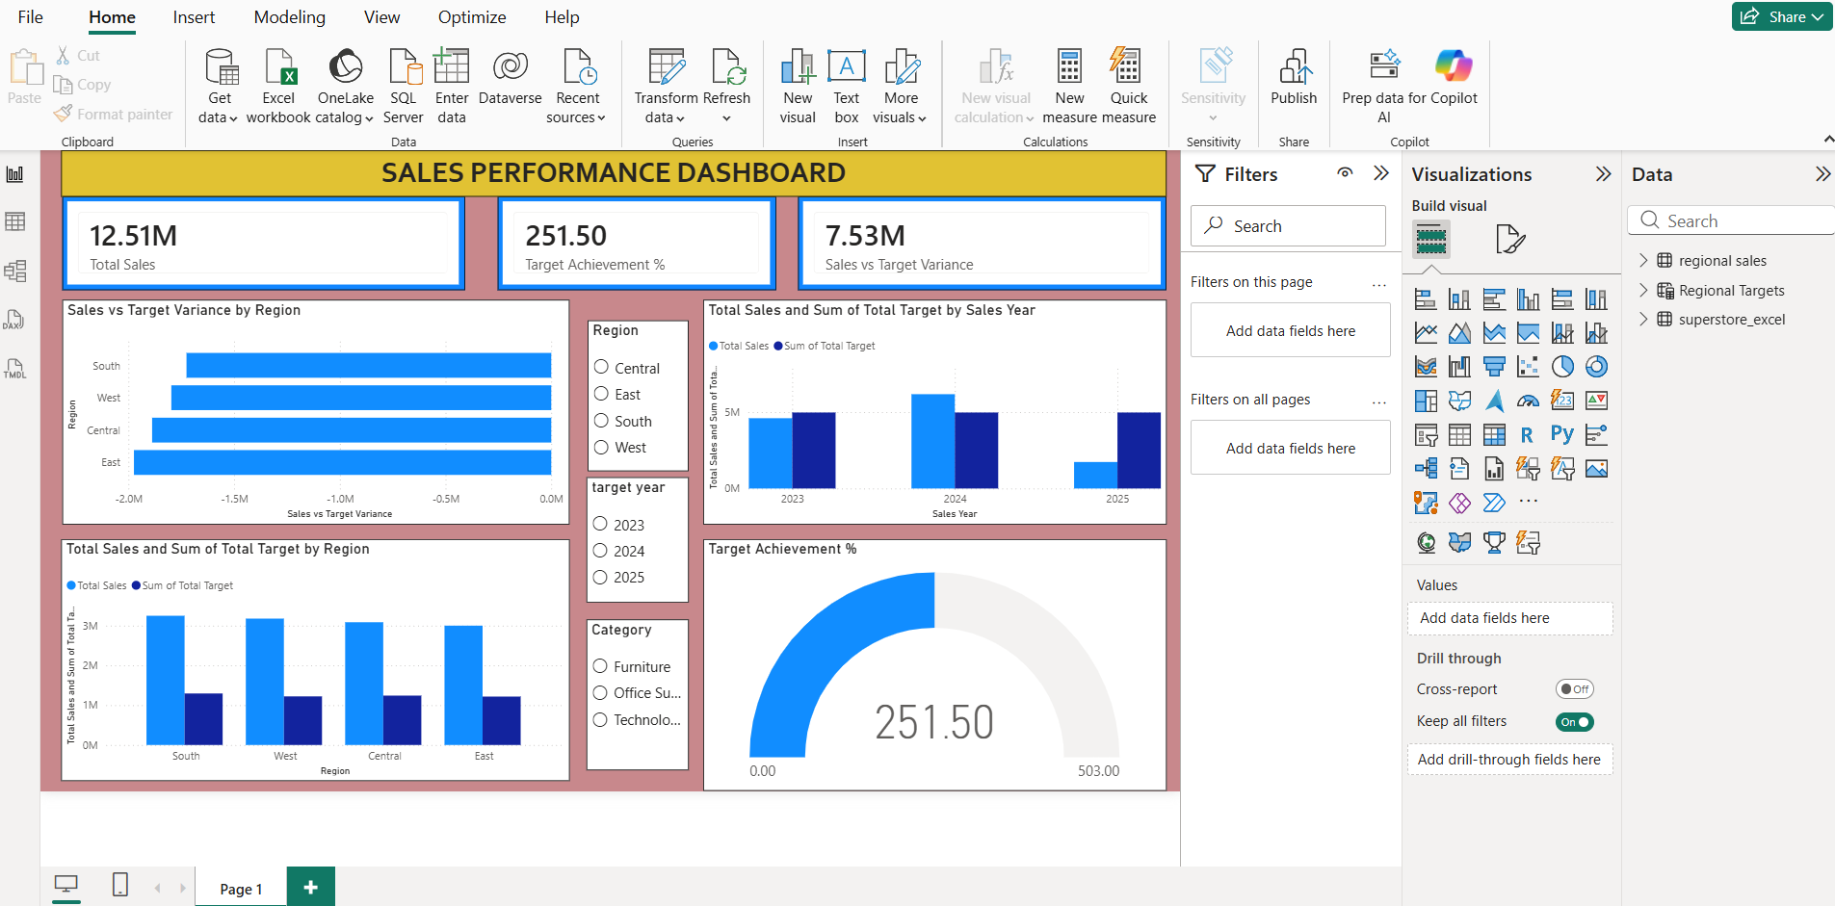
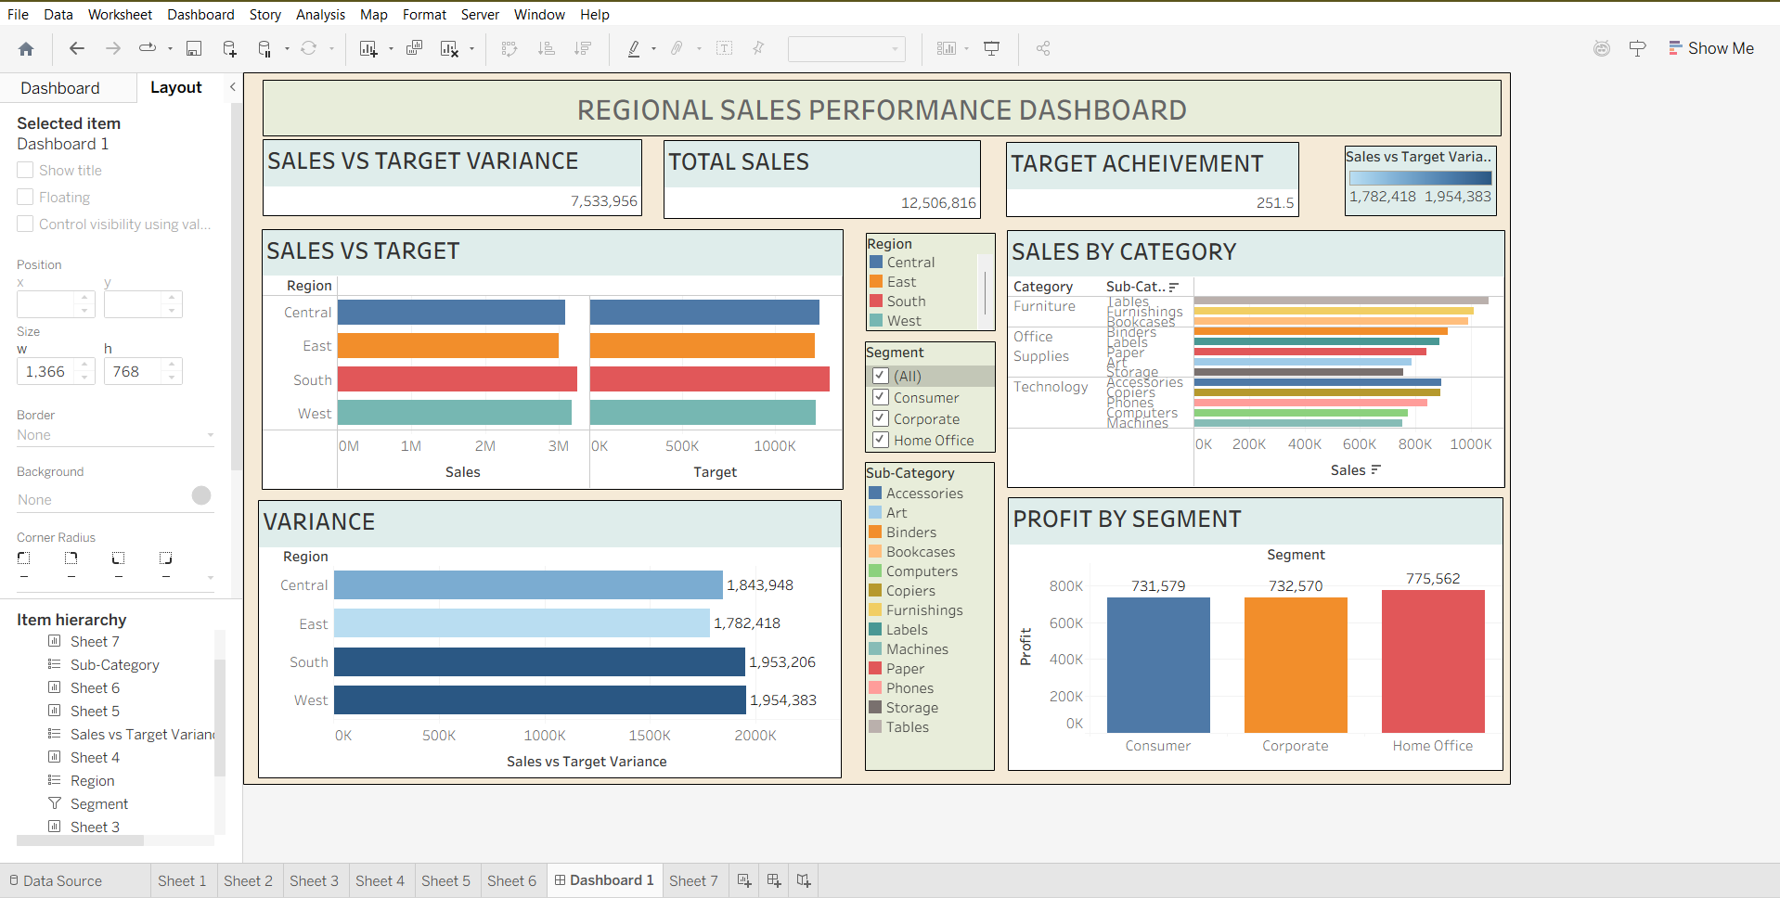

POST-LAB QUESTIONS

1. How did integrating the sales targets data provide a more complete analytical picture than using the sales data alone?
Integrating sales targets allowed comparison of actual performance against goals, revealing not just how much was sold but whether regions met, exceeded, or fell short of expectations — insight impossible with sales data alone.

2. Describe the type of join or relationship you used to combine the two datasets and explain why it was the appropriate choice.
A many-to-one relationship was used, linking multiple sales records to a single regional target record via the Region field. This was appropriate since each region has one target but many individual sales transactions.

3. What challenges, if any, did you face regarding data granularity or mismatched keys (e.g., different region names) between the two sources?
Challenges included inconsistent region naming between datasets, which was resolved by standardizing names before creating relationships. Granularity mismatch (transaction-level vs. yearly targets) required aggregating sales data to match the target's time frame.

4. How can creating variance calculations (e.g., Sales vs. Target) help a business manager make better decisions?
Variance calculations highlight underperforming or overperforming regions immediately, helping managers prioritize interventions, reallocate resources, and set realistic future targets.

5. What other data source (e.g., marketing campaign data, customer demographics) could you integrate to further enrich this analysis, and what new insights might it provide?
Integrating marketing campaign data could reveal which campaigns drove sales spikes, while customer demographic data could show which segments contribute most to target achievement, enabling more targeted marketing and sales strategies.

RESULT:

The retail sales and regional targets datasets were successfully connected, cleaned, and integrated in both Tableau and Power BI. By creating relationships between the sources, a unified data model was built. The resulting comprehensive dashboard visualized sales performance against set targets, enabling variance analysis and providing deeper, context-rich insights into regional performance that were not possible with a single data source.

ASSESSMENT

Description |  | Max Marks | Marks Awarded
Pre Lab Exercise |  | 5
In Lab Exercise |  | 10
Post Lab Exercise |  | 5
Viva |  | 10
 | Total | 30
 | Faculty Signature

